**Deerwalk Institute Of Technology**

**Database Administration**

**Lab: 6**

**Submitted By: Submitted To:**

**Name: Sagar Giri Narayan Chalise**

**Roll No. 205**

**Date:**

Managing Roles

1. Create a user.
2. Create a role.
3. 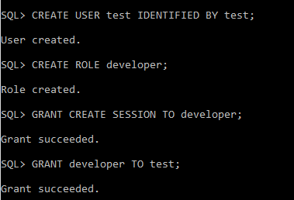Assign Role to the user.

Granting Privileges